JUnit Testing Exercises
EXERCISE 1: SETTING UP JUnit

SCENARIO:
You need to set up JUnit in your Java project to start writing unit tests.
CODE:
import org.junit.Test;
import static org.junit.Assert.*;

public class Test {
@Test
public void testAddition() {
int result = 2 + 3;
assertEquals(5, result);
}
}

OUTPUT:
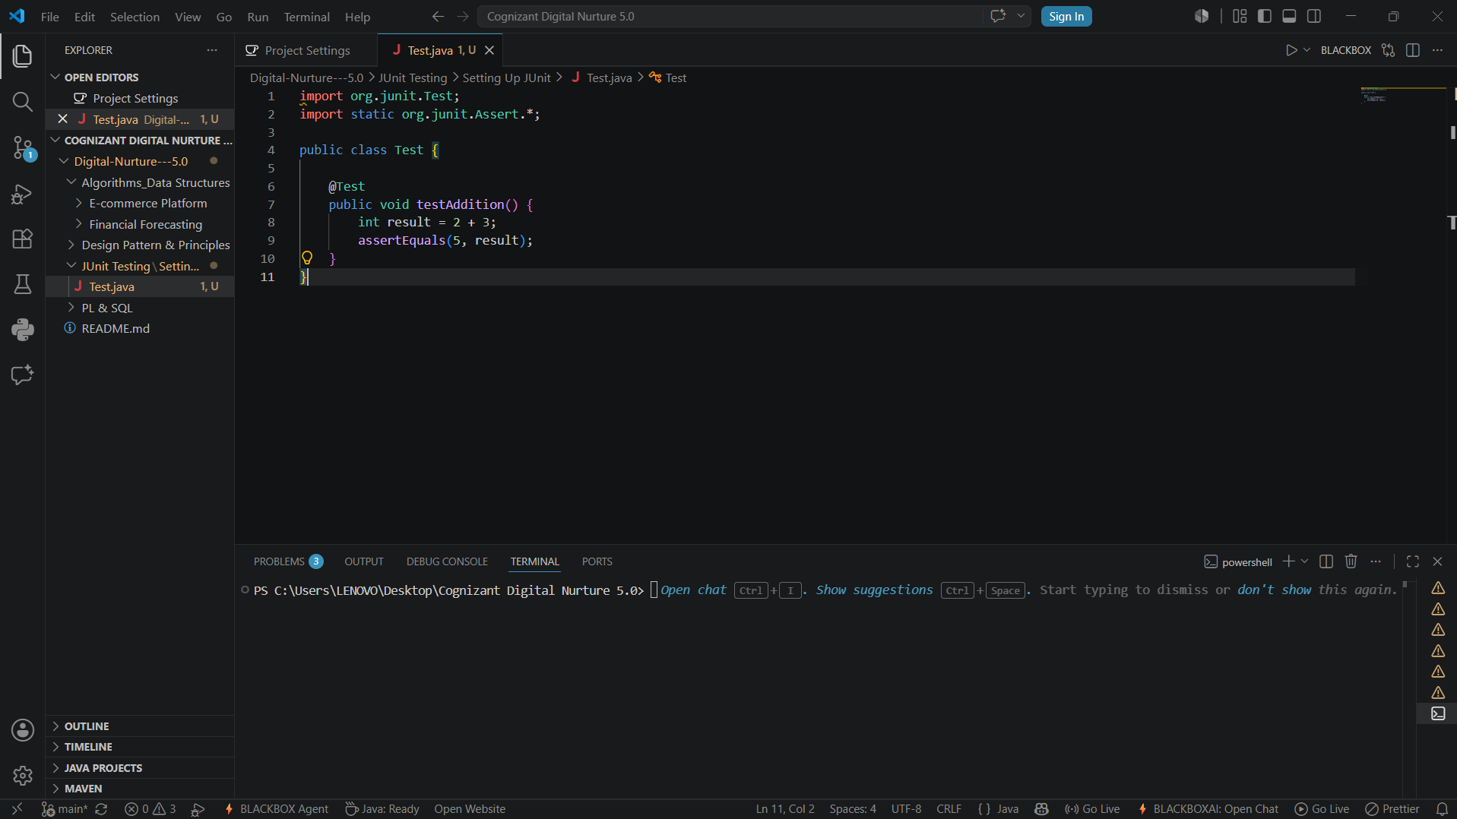
EXERCISE 3: ASSERTIONS IN Junit

SCENARIO:
You need to use different assertions in JUnit to validate your test results.

CODE:
import org.junit.Test;
import static org.junit.Assert.*;

public class AssertionsTest {
@Test
public void testAssertions() {
// Assert equals
assertEquals(5, 2 + 3);
// Assert true
assertTrue(5 > 3);
// Assert false
assertFalse(5 < 3);
// Assert null
assertNull(null);
// Assert not null
assertNotNull(new Object());
}
}

OUTPUT:

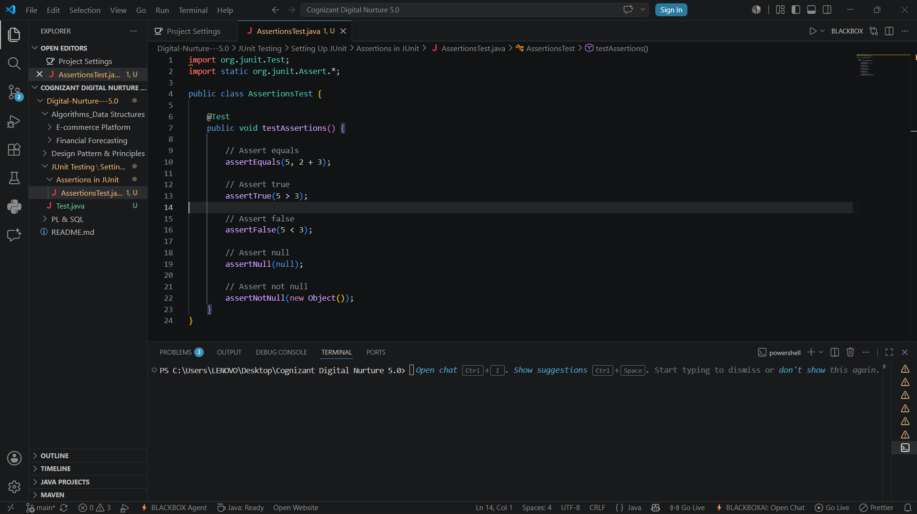

EXERCISE 4: Arrange-Act-Assert (AAA) Pattern, Test Fixtures, Setupand Teardown Methods in JUnit

SCENARIO:
You need to organize your tests using the Arrange-Act-Assert (AAA) pattern and use setup and teardown methods.

CODE:
import org.junit.Before;
import org.junit.After;
import org.junit.Test;
import static org.junit.Assert.*;

public class AAATest {
private int number;
@Before
public void setUp() {
number = 10;
}
@Test
public void testAddition() {
// Arrange
int value = number;
// Act
int result = value + 5;
// Assert
assertEquals(15, result);
}
@After
public void tearDown() {
number = 0;
}
}

OUTPUT:

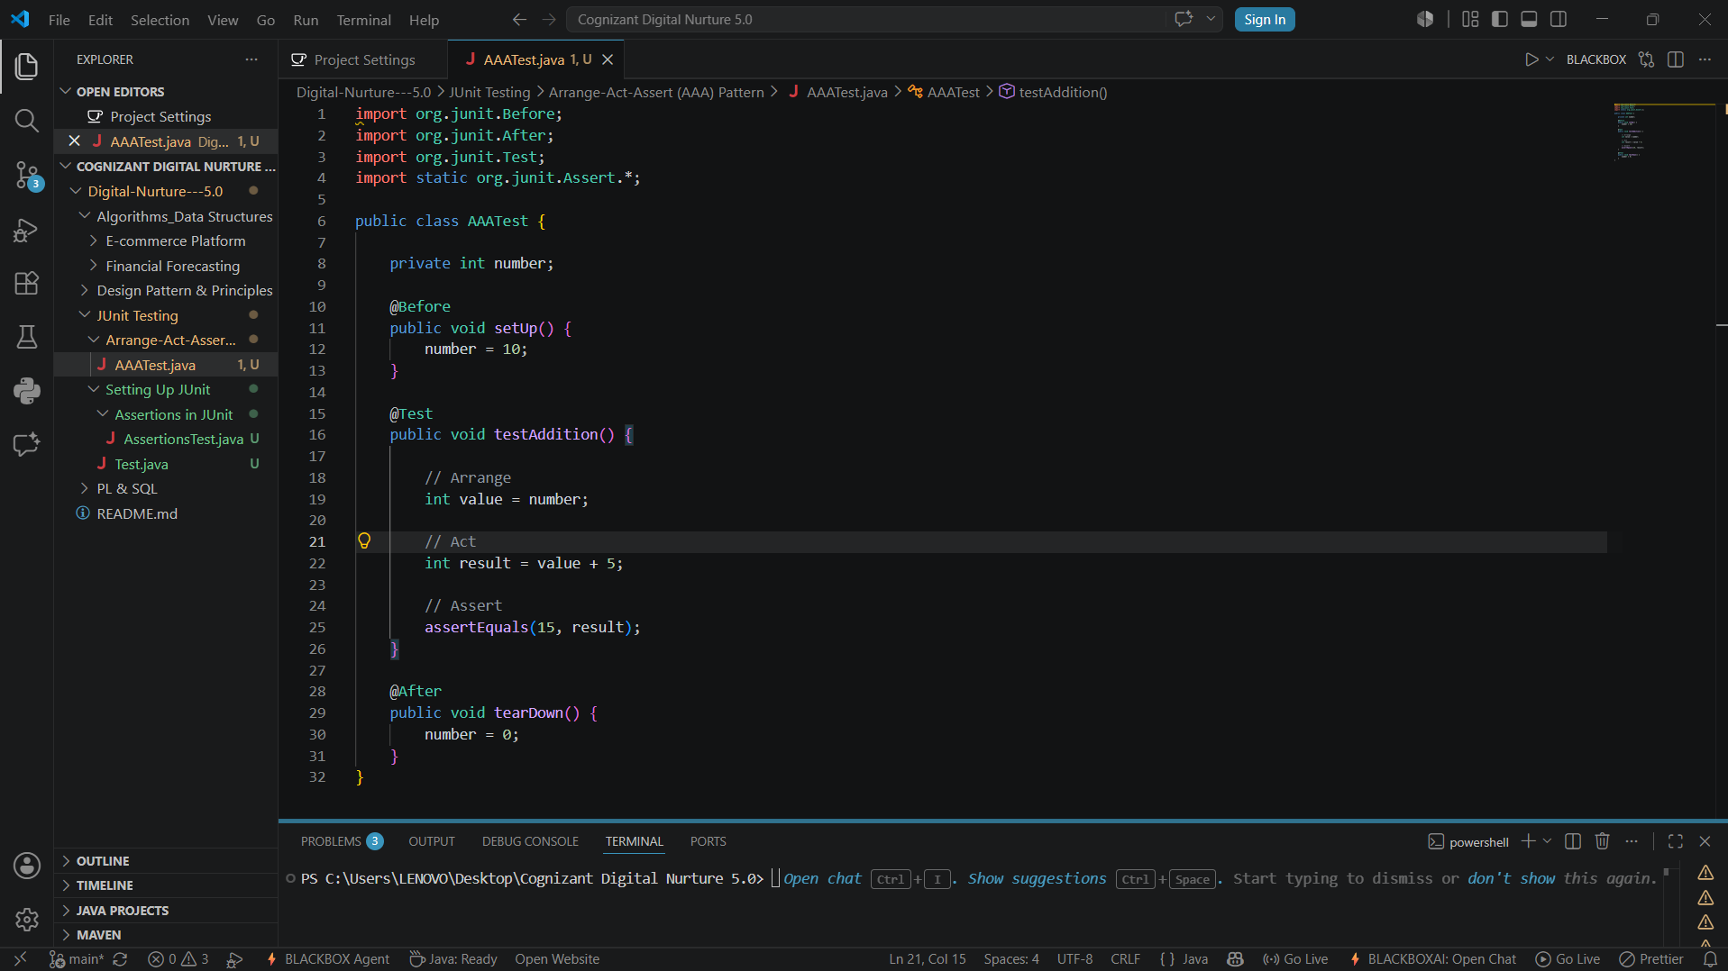

Mockito Hands-On Exercises
Exercise 1: Mocking and Stubbing
SCENARIO:
You need to test a service that depends on an external API. Use Mockito to mock the external API and stub its methods.

CODE:
ExternalApi.java
public interface ExternalApi {
String getData();
}

MyService.java
public class MyService {
private ExternalApi api;
public MyService(ExternalApi api) {
this.api = api;
}
public String fetchData() {
return api.getData();
}
}

MyServiceTest.java
import static org.mockito.Mockito.*;
import static org.junit.Assert.assertEquals;
import org.junit.Test;
public class MyServiceTest {
@Test
public void testExternalApi() {
// Create mock object
ExternalApi mockApi = mock(ExternalApi.class);
// Stub method
when(mockApi.getData()).thenReturn("Mock Data");
// Use mock object
MyService service = new MyService(mockApi);
String result = service.fetchData();
// Verify result
assertEquals("Mock Data", result);
}
}

OUTPUT

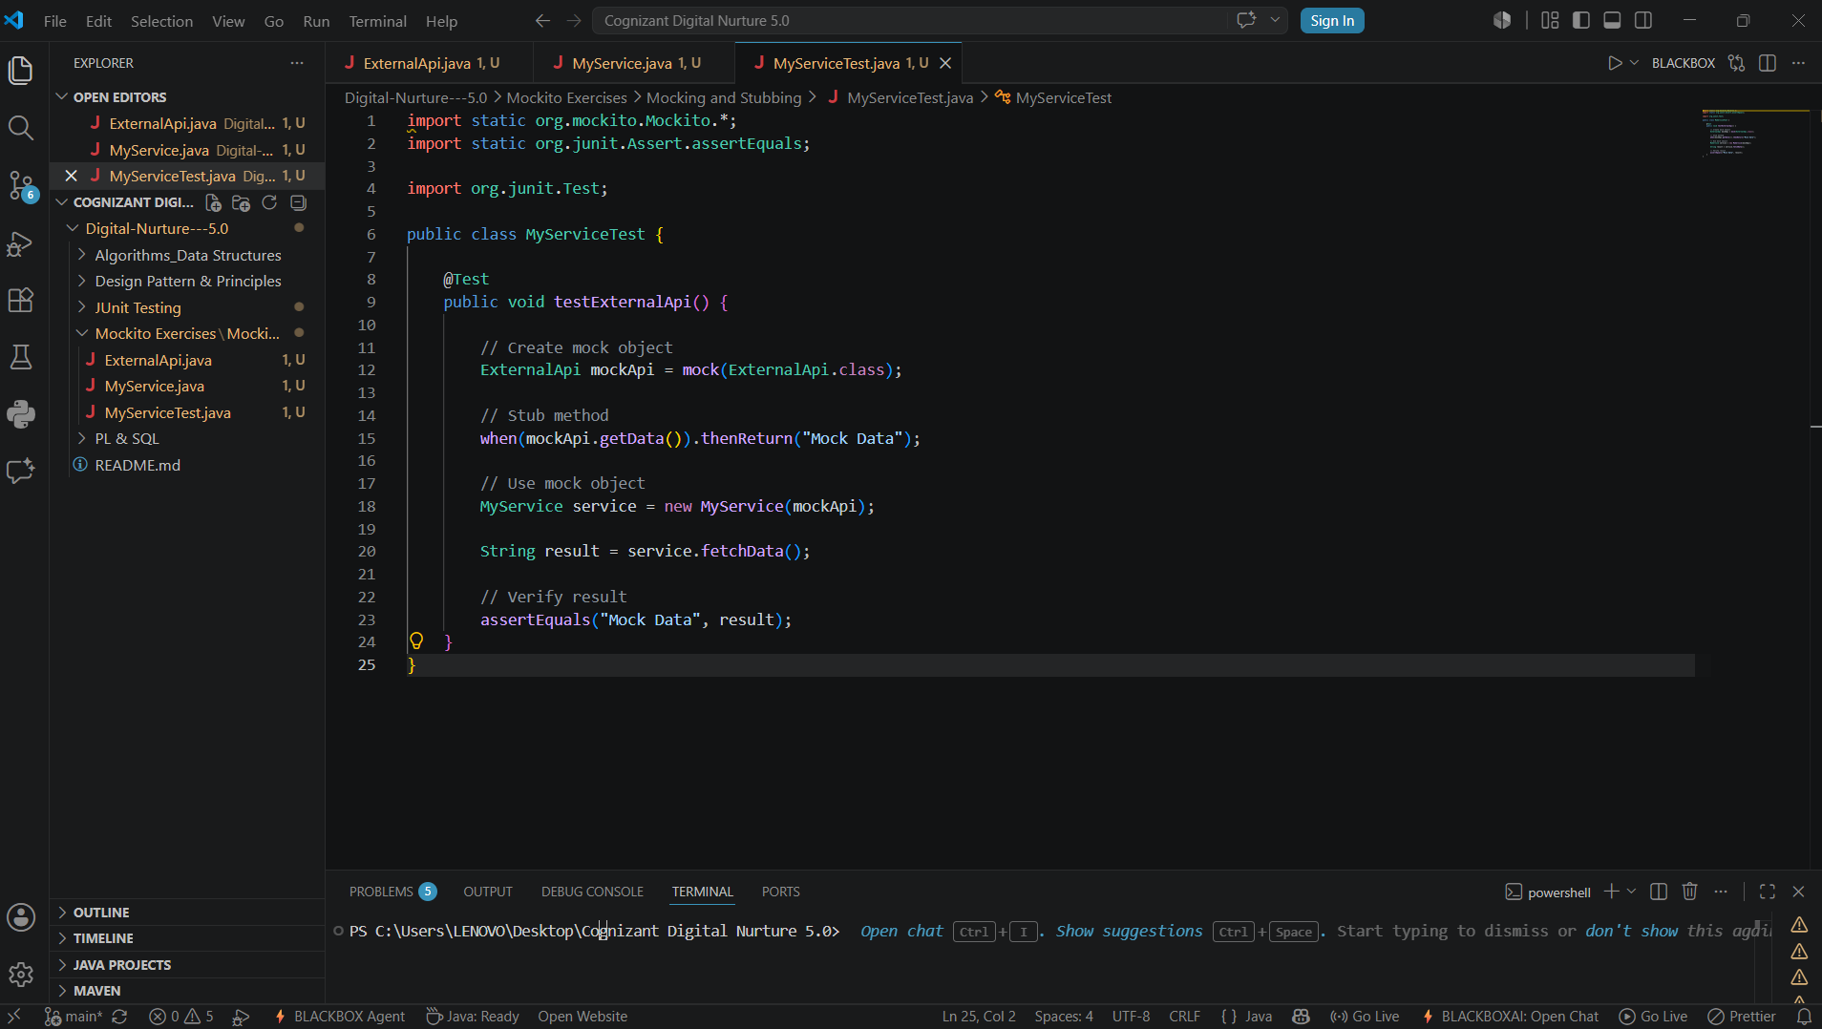

Exercise 2: Verifying Interactions
SCENARIO:
You need to ensure that a method is called with specific arguments.

CODE:
ExternalApi.java
public interface ExternalApi {
String getData();
}

MyService.java
public class MyService {
private ExternalApi api;
public MyService(ExternalApi api) {
this.api = api;
}
public String fetchData() {
return api.getData();
}
}

MyServiceTest.java
import static org.mockito.Mockito.*;
import org.junit.Test;
public class MyServiceTest {
@Test
public void testVerifyInteraction() {
// Create mock object
ExternalApi mockApi = mock(ExternalApi.class);
// Use mock object
MyService service = new MyService(mockApi);
service.fetchData();
// Verify interaction
verify(mockApi).getData();
}
}

OUTPUT:
